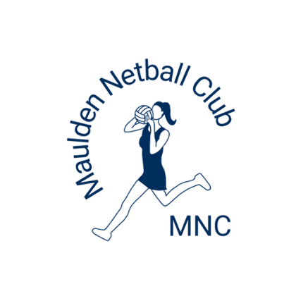
Maulden Netball Club
Payment Information 2025-26

Maulden Netball Club Payment Details
Sort Code: 60-01-16
Account Number: 45022593
Reference: Year group, child’s surname, first name initial(in capitals) e.g. Year 7websterS

If paying in instalments, please ensure you set up a standing order for the amount specified for the relevant age group.

Year 3
Annual Fees: £120
Make a direct bank transfer via internet banking.

Paying in Full:
15th September 2025 - £120

Paying in Instalments:
15th September 2025 - £21
9 further payments of £11 due on the 1st of each month, October 2025 – June 2026.

Year 4/5/6
Annual Fees: £145
Make a direct bank transfer via internet banking

Paying in Full:
15th August 2025 - £145

Paying in Instalments:
15th August 2025 - £25
10 further payments of £12 due on the 1st of each month, September 2025 – June 2026.

Year 7/8
Annual Fees: £170
Make a direct bank transfer via internet banking

Paying in Full:
15th August 2025 - £170

Paying in Instalments:
15th August 2025 - £25
10 further payments of £14.50 due on the 1st of each month, September 2025 – June 2026.

Youth
Annual Fees: £195
Make a direct bank transfer via internet banking

Paying in Full:
15th August 2025 - £195

Paying in Instalments:
15th August 2025 - £25
10 further payments of £17 due on the 1st of each month, September 2025 – June 2026.

Adult
Annual Fees: £195
Make a direct bank transfer via internet banking

Paying in Full:
15th August 2025 - £195

Paying in Instalments:
15th August 2025 - £25
10 further payments of £17 due on the 1st of each month, September 2025 – June 2026.

