**Junior League – Parent information**

***Meeting Point***

**Players will need to meet their coaches on the grass area outside the courts. If you are going to be late please message on the chat so someone can pass this information onto the coaches.**

***Contacting the Coach***

**Sundays are really busy, and we do not check our phones when we are coaching. If your daughter is unwell please let us know as soon as possible. We plan our rotations after training on Saturdays; a lot of thought goes into them so it does take time to change.**

***Clothing***

**The league very rarely cancel matches due to bad weather so please make sure that your daughter is suitably dressed for the weather. They will not be on court all of the time so will need a hoodie and a waterproof if rain is forecast.**

***Grading Tournament***

**The league run this so they can organise the teams into divisions so matches are suited to the level of the players and more enjoyable. To enable this the tournament matches are shorter in duration and the girls have more matches on each day. It is a ‘crazy day’ for the coaches and helpers (who are all volunteers) so pick ups and drop offs on time are even more important.**

***Toilets***

**These are located inside the school building. There are not many so please make sure that your daughter ‘goes’ before they leave the house.**

***Equipment***

**The girls do not need to bring their ball to the matches but they will need a water bottle. It is club policy that they cannot play (or train) if they do not have one as dehydration can be very harmful. It therefore becomes a safeguarding issue.**

***Injury***

**If your daughter is injured and cannot play they may still be able to be on court if numbers allow. Each team is only allowed 10 players. If they are injured during a match we will treat them and decide if they need to leave early.**

**If your daughter has an inhaler they must place it in the first aid bag on arrival so we can access it quickly if required.**

***Other Events***

**At the end of the season, there may be other events run by the league on a Sunday morning. The first of which is a Cup and Plate Tournament, and the second of which is the Charity Tournament. Often the presentation of the trophies by the league happens at the end of the Charity Tournament.**

***Venue details***

**Top Tip**

**Traffic can build up on the way home as you get closer to the bypass**

**If you exit right onto Mile road you can access the A421 this way as well**

**Address:**

**Bedford Academy**

**Mile Road**

**Bedford**

**MK42 9TR**

**Map**

**Academy Entrance**

**Entrance to car park**

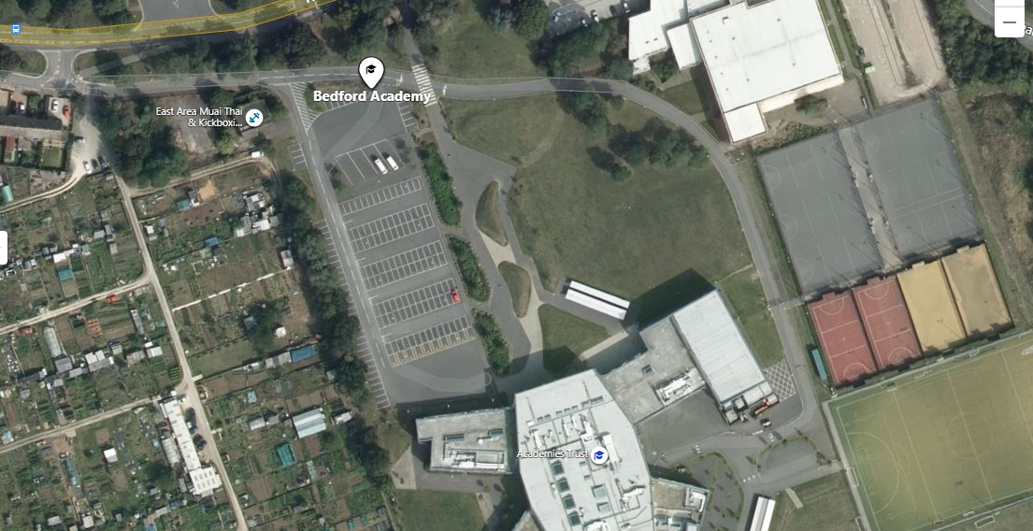

**Courts**

**Toilets**

**Meeting point**