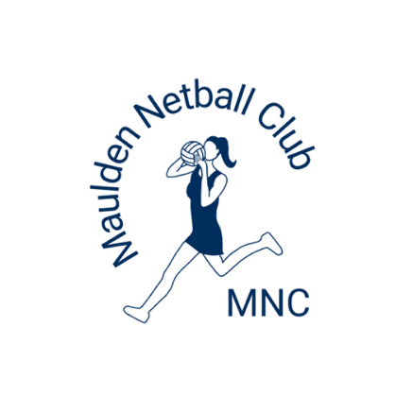
Maulden Netball Club
Kit Policy 2025/26

Purpose of this policy:
Is to provide guidance for parents and club officials in obtaining, providing, replacing, and looking after club kit and to form a reference point for those joining the club for the first time.

What is kit and when is it issued?
We strongly believe that the wearing of kit by our players encourages team spirit and pride in representing Maulden Netball Club. It is also useful for coaches, buddies, or tournament/league officials to help easily identify our players in competitions or match situations. Our club colours are navy blue, light blue and white, and all kit has the Maulden Netball Club emblem.

We ask that kit is worn only whilst playing matches or training for Maulden Netball Club and that it should not be used at any other time without permission from the club. Full kit MUST be worn for all Maulden Netball Club matches.

All kit provided by the club will remain the property of Maulden Netball Club.

All kit MUST be returned to the club upon your child leaving.

Kit Issued
Year 3 to Year 6 – Top and skort to be provided by the club.
Year 7 - Dress to be provided by the club.
Year 8 upwards – Personalised dresses to be purchased by parents.

Additional Kit that can be purchased by parents
All years – Personalised Hoodies, Bench Coat
Year 7 upwards – Training Tops personalised with name
Other additional kit is available to order from our suppliers at Prestige in Flitwick or Barton.

Replacement Kit
We expect that all kit provided by the club is kept clean and in good repair and that the cost of any replacement kit incurred through loss or damage by mistreatment or neglect is paid for by the club member concerned. Parents and players will be expected to notify the club of any loss or damage as soon as possible.

Sponsorship:
From time to time, the club is fortunate to receive sponsorship from local businesses or parental support within a team to fund the purchase of new kit. We encourage coaches benefiting from such donations to include the name of their sponsor on their kit and decide, in consultation with their players, what items of additional kit they would like. Sponsorship donations may be supplemented by a parental contribution to buy additional items of kit; in cases where this might cause financial hardship, the Committee has discretion to assist with funding provided they are alerted to potential parental difficulty. In all cases where sponsorship is involved, the secretary will arrange for a letter of thanks to be issued to the sponsor and ensure wherever possible that photographs of items of kit are sent in recognition of the generosity of the sponsor. The club has no say in when or how sponsorship might be offered by an individual or organisation.

Grant applications:
From time to time, the club may apply to organisations for help towards buying new kit.

Kit Rules:
- All kit remains the property of Maulden Netball Club (except personalised dresses for Year 8+ paid for and owned by players.)
- All kit should be kept clean and in good repair.
- All loss or damage must be paid for by the club member.
- The player or their parent/carer is asked to notify the Club of any loss or damage to the kit as soon as possible.
- If you need to replace an item of kit, please speak to your coach or admin who will advise you who to contact to obtain a replacement item.
- The kit issued is for use only whilst training or playing for Maulden Netball Club and should not be used at any other time without having received authorisation from the Club.
- Full playing kit must be worn for all Maulden Netball Club matches. Players are permitted to wear a white top underneath.
- For training, players are permitted to wear leggings/bottoms in black or navy.
- All kit will be returned to the Club when the player leaves the Club rather than being donated to charity shops.
- Any new kit required due to old kit being outgrown will need to be purchased by the player or their parent/carer if there are no club replacements available.

