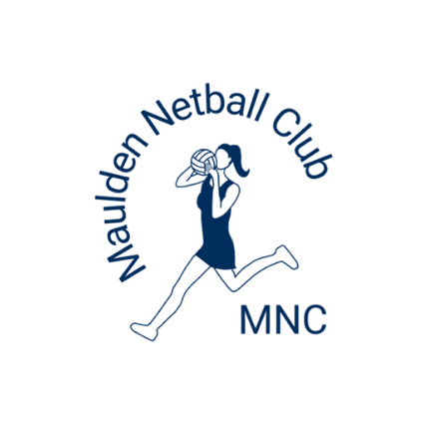
Maulden Netball Club
Registration Pack - 2025/26

We look forward to welcoming you as a new or returning member to the forthcoming 2025/26 netball season (September 2025 to July 2026) Please ensure you read through all documents in the MNC Welcome Pack (listed below) as there have been some changes from last season.

Registration takes place annually and we ask you to complete the Registration Google Form to provide us with your child’s personal details, medical history, and emergency contact details. Please note, all members wishing to return must complete the Registration Form by 15th August 2025. This enables us to be fully prepared for next season, by reserving spaces for any continuing players and give any remaining places to those on our waiting list.

MNC Welcome Pack
The following documents form the MNC Welcome Pack. Please ensure you read and adhere to all of them as required by the online registration form:
- MNC Welcome Letter (this) - Player Code of Conduct (to be read and signed by the player)
- Parent, Carer and Spectator Code of Conduct (to be read and signed by parent/carer)
- Social Media Policy (to be read and signed by parent/carer and the player)
- Safeguarding Policy
- Kit Policy
- Payment Information

England Netball Affiliation 2025/26
Registration opens on 1st August 2025.

For data protection and affiliation purposes to England Netball there is a requirement to complete a separate England Netball registration. Affiliation can be completed using the link below. Please ask your year group admin if you require assistance with affiliation.

Please affiliate/buy membership for the correct categories: National/Region/County/Club (Maulden NC), these will populate when you link to Maulden NC as a club. → 144171

https://engage.englandnetball.co.uk/EnglandNetball

If your child is not affiliated to England Netball, they will be unable to play in any of the leagues that we enter.

Fees
This year, we are very fortunate that there has been a minimal increase in fees, despite increasing court hire, umpiring and equipment costs. This is entirely due to the support of parents/carers and spectators in our fundraising efforts over the past year but especially everyone who helped support the refreshments stall at the Bedford Junior League. The 2025/26 fees for each year group are on the Payment Information document, and can also be found on the membership page of our website.

These can be paid in full through BACS payment, see the payment information document for more information. Alternatively, there is an option to pay in 10 instalments. The initial registration payment is required before registering to confirm a place next season, followed by 10 monthly instalments from September 2025 through to June 2026.

If you choose to make payments monthly, and do not adhere to the correct payments on the 1st of each month, the club reserves the right to withdraw the monthly payment option and request payment in full. Failure to pay fees correctly, may result in your child being unable to continue to train or play matches until they are brought up to date. If you would like to speak to us regarding payment of fees, please speak to your year group admin, or any other contact at the club.

*Please see Payment Information Document for instructions for setting up your standing order or bank transfer

MNC is a not-for-profit organisation and fees are intended only to cover the costs we incur. These include:
- Court hire at Redborne for weekly training.
- Sports Hall hire at Redborne for wet days or specific fitness training.
- Player and team entry fee for League.
- Court hire for entry in specified League.
- Umpiring fees.
- Non-Personalised Club branded kit to be used on match days (as outlined in our kit policy).
- Course fees for volunteers (DBS, Safeguarding, Coaching Qualifications, First Aid Qualifications, CPD, Umpiring Qualifications).
- Training equipment.
- Full and continuous first aid supplies for each year group.
- Discounted entry to MNC tournaments.

All adult committee members, coaches, admins and team managers are volunteers. They do not get paid for the countless hours they dedicate to coaching and supporting your children. planning sessions, organising tournaments, running training, attending courses, I would like to take this opportunity to thank them for the time they commit to the club.

Training
Training will take place on Saturday mornings for Years 3 – 8, and Monday evenings for Youth and Adult at Redborne Upper School North site. Times will be advised via the WhatsApp groups as they are confirmed. They will also be available on the website FAQ page under Training.

There may be a break from training during half term weeks – this decision will rest with your year group coach, and you will receive 2 weeks’ notice.

2025/26 Season
Once training dates and times have been decided, we will notify everyone via Whatsapp and will make it available on the website.

Inclement Weather.
There may be short notice of these training times due to inclement weather. These will be communicated via WhatsApp.

Photography and use of photographic images
From time to time, the Club may wish to take photographs or film the players during raining or matches team photographs. These are for use on our social media pages, website, promotional or publicity material specific to the Club or media articles about the Club.

Parents/Carers or spectators are not permitted to take photos or videos of their child participating in training or matches. This is both a Club and League policy. This is not only to safeguard our own players, but those of other clubs.

The registration form includes a consent form if you wish that your child be blurred before these images are published.

Finally…
A list of all positions held at the club will be published on the website in September. We are always looking for more volunteers, so if you would like to become more involved in any aspect of the club, please speak to your year admin or coach. The club will pay for any appropriate courses required. Also, if you have a special skill or business contact, we might be able to make use of it within the club, please speak to one of us. In the unfortunate event of you experiencing any difficulties or issues you are not able to resolve alone, we suggest that firstly you speak to your child’s coach. Here’s looking forward to another wonderful year for the Club!

Anna Tiana
Chair
Maulden Netball Club

