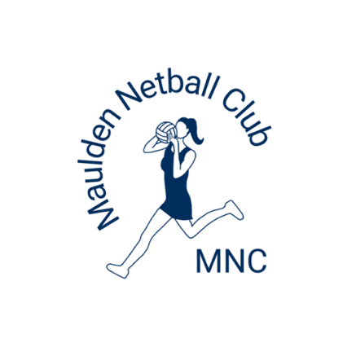
Maulden Netball Club
Player Code of Conduct - 2025/26

To help you and others in the netball family have fun, feel safe and enjoy netball, you are expected to agree to the following high standard of behaviour.

England Netball sports ethics are:

RESPECT TEAMWORK ACHIEVEMENT FUN

By registering to play for Maulden Netball Club, you are agreeing that you will:

NEVER bully, show aggression, or post anything unfriendly or hurtful on social media or by text.
ENCOURAGE new members and respect that everyone is different.
TELL the club Safeguarding Officer or an adult I trust about my behaviour or situations I feel worried about.
BE a team player by being loyal, friendly and kind to my teammates and opponents.
ALWAYS play fairly to the rules and show respect to the umpires.
LISTEN to my coach and always try my best.
LET someone in charge know if I leave a netball venue.
RESPECT my team manager, coaches and official’s decisions.
UNDERSTAND that everyone has different strengths and recognise that we play better as a team.
ENSURE I wear suitable kit for training and matches with my hair tied back, short nails and no jewellery.
SHOW great sportsmanship and teamwork, whether I win or lose and always thank everyone involved – the game would not go on without them!
LOVE the game!

NETBALL RULES!!

